PERFORMANCE TESTING

**JMeter**

* Performance testing tool
* Provided by Apache
* It is an open source and is written in java
* Results are n the form of graph, chart etc.
* JMeter can be integrated with selenium for automated testing.

**1.Installation.**

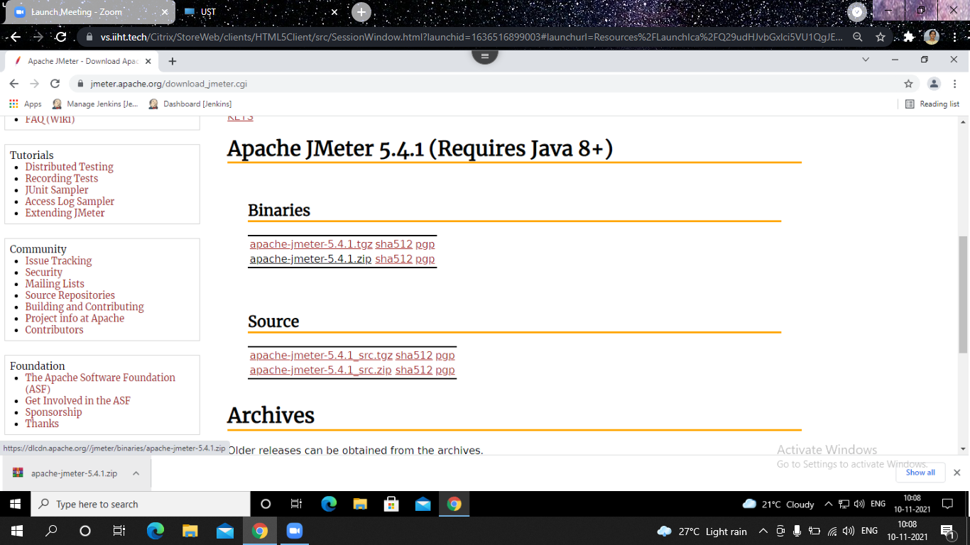

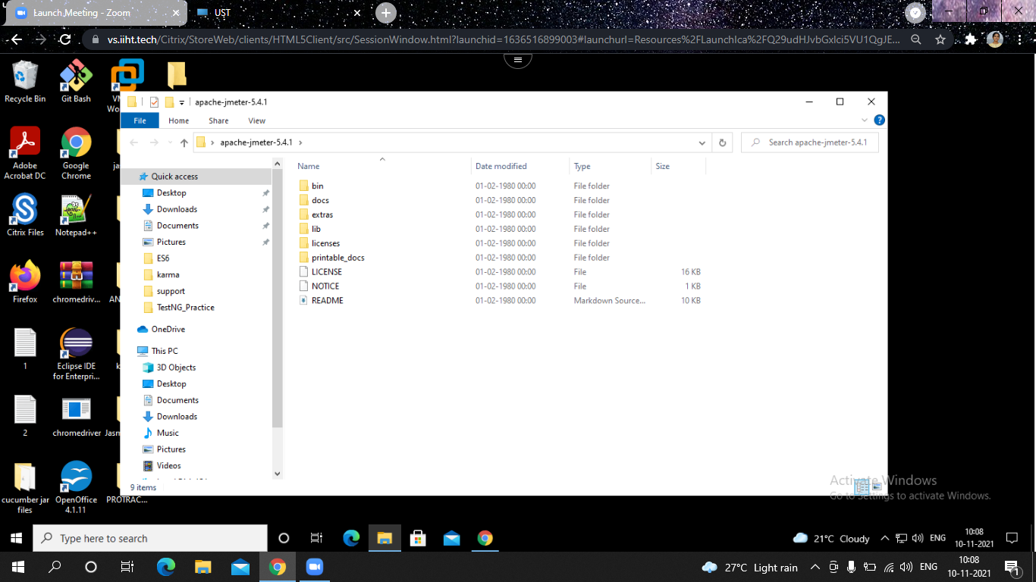

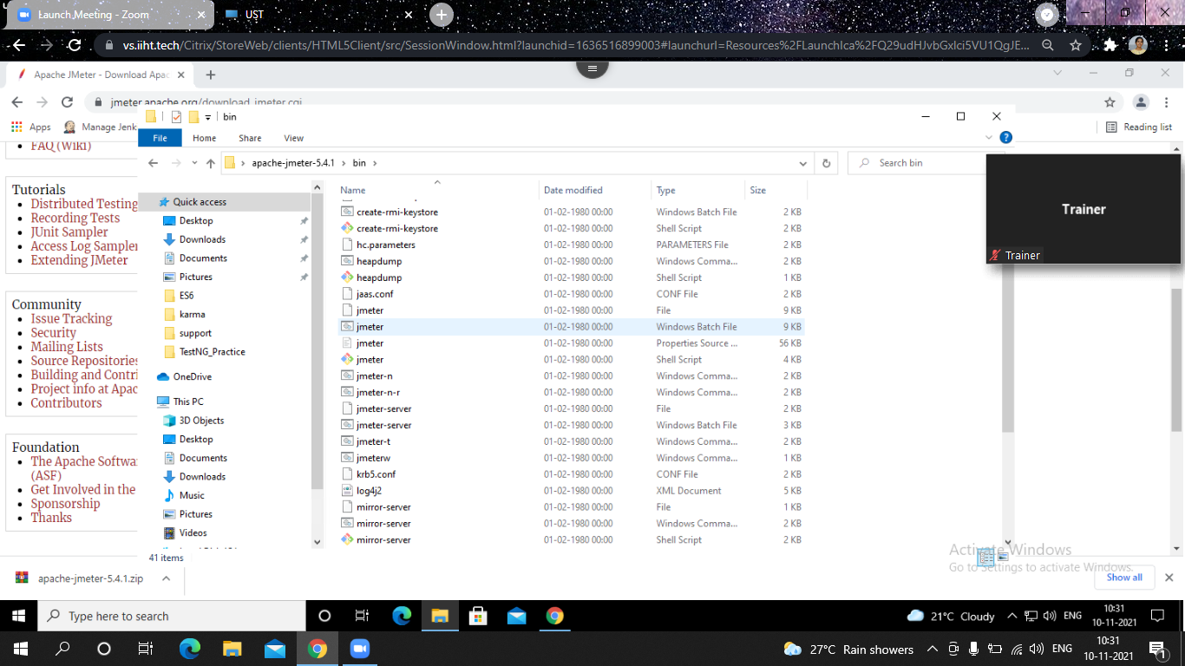

The following image shows the default Apache JMeter interface -

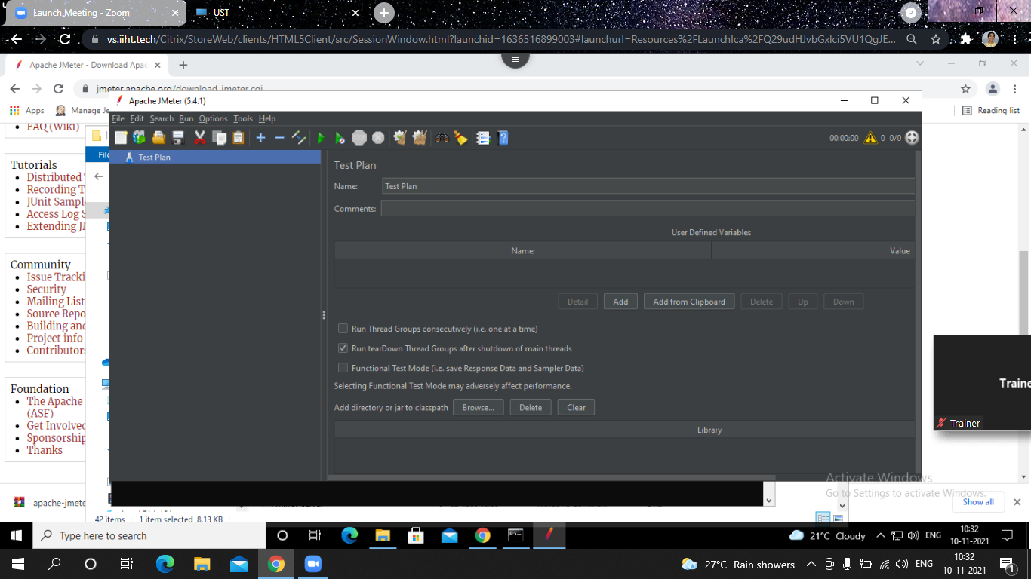

Working of JMeter

JMeter sends requests to a target server by simulating a group of users. Subsequently, data is collected to calculate statistics and display performance metrics of the target server through various formats.

JMeter work flow Diagram:

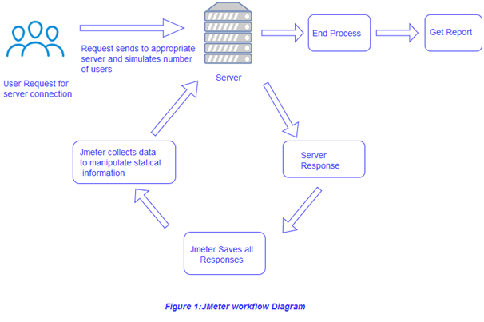

## 2. Create test plan

A useful test plan is created with minimum 3 components –

* **Thread Group** – contains the simulation of multiple concurrent users. A single thread represent a single user. We can create any number of threads to put the desired load on the application. It also help us in scheduling the delay between two threads, and any repetition of request batches.
* **HTTP Request** – consist the HTTP request configuration which thread group will be invoking. It is the application URL which you want to load test.
* **Listener** – helps in viewing the result of the whole testing process. There are multiple listener available in JMeter to verify the testing results.

#### 2.1. Create Thread Group

To create a thread group, navigate to ‘Right click Test Plan -> Add -> Threads -> Thread Group’.

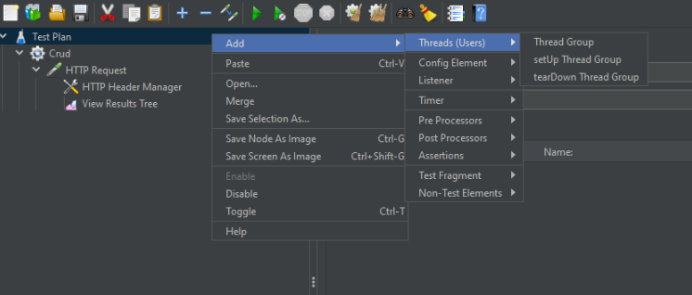

Name the thread group and save it to any location in your workstation.

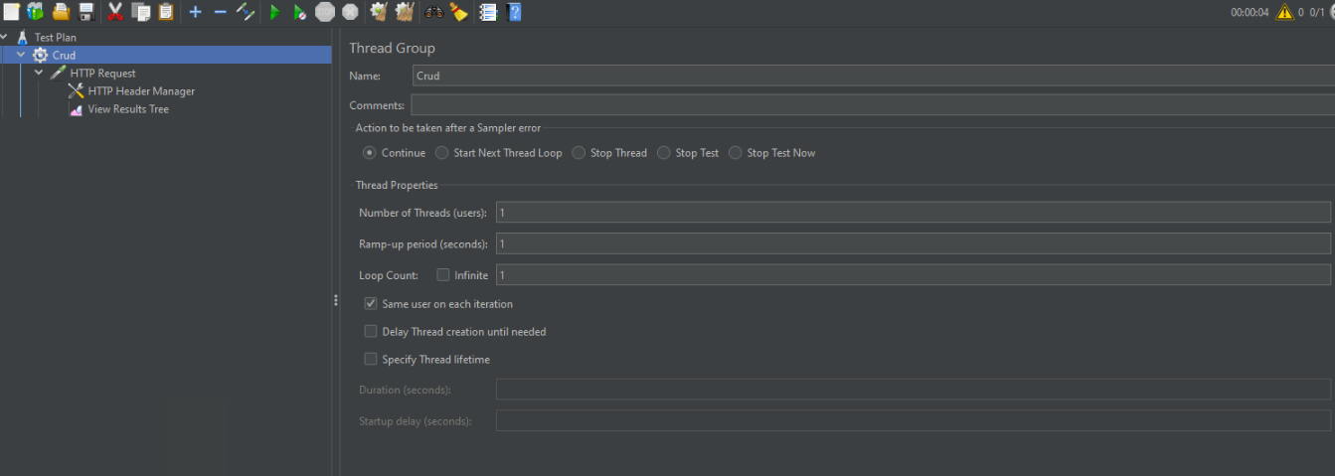

#### 2.2. Create HTTP Request

To add HTTP request details, navigate to ‘Right click thread group -> Add -> Sampler -> HTTP Request’.

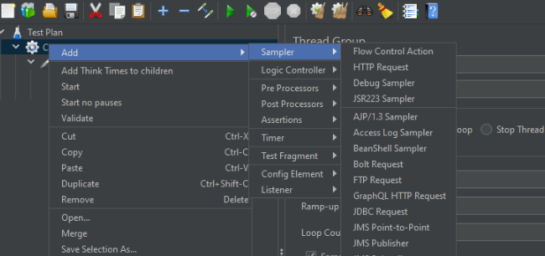

Fill in the application URL details which we are going to test. The API URL is 'http://localhost:8080/book'.

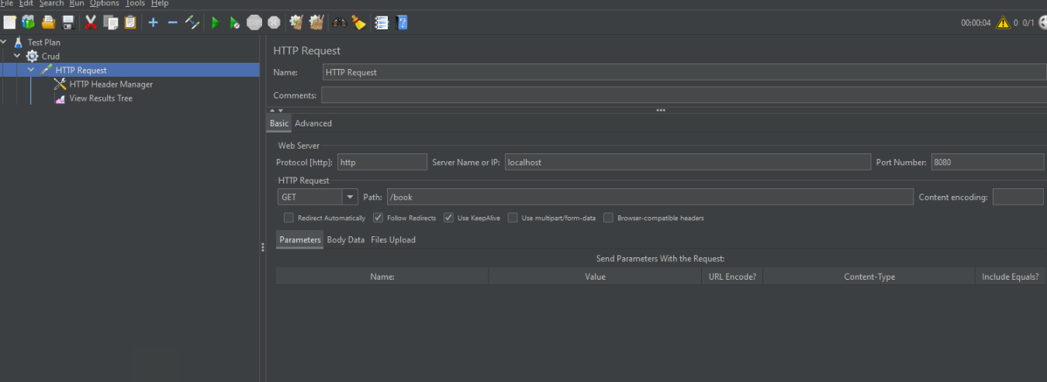

#### 2.3. Add Listener

To see the results of test plan, add listener named “” by navigating to ‘Right click thread group -> Add -> Listener -> View Results Tree’.

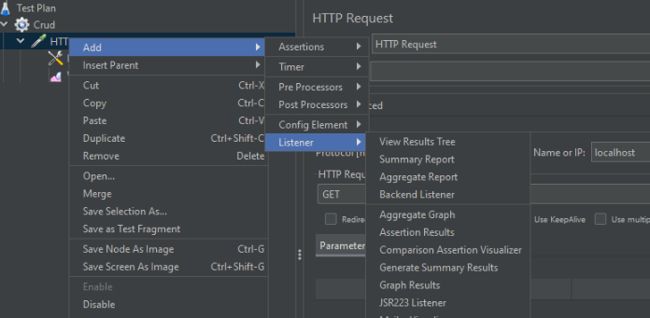

## 3. Perform load testing

To perform the load testing, start the thread group using the green play icon at the top ribbon in tool.

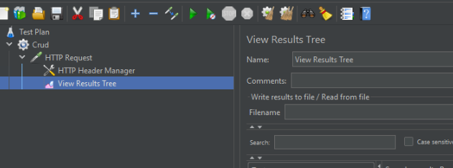

Let all threads run and invoke the configured application URL. After the test is finished, we can review the load test results in consolidated manner in listener tab.

